**Introduction to Atlas-ti Software**

**for Qualitative Data Analysis**

**If you don’t have Atlas.ti, download Atlas.ti 23 Trial version for Windows here**

<https://atlasti.com/free-trial-version/>

Please read the trial period and limitations.

**Workshop Instructions:**

* Download CCSS-AtlastiMaxQDA-Workshop files
  1. Go to <https://cornell.box.com/s/78x8nr9zpvcp2491gg7uxgsfy1sk80cl>
  2. You may be prompted to enter your Cornell netid and password
  3. Click on the ellipses button (…) and select Download
  4. The CCSS-AtlastiMaxQDA-Workshop.zip will be downloaded to your default Downloads folder
* Unzip the CCSS-AtlastiMaxQDA-Workshop.zip onto your local drive.  Choose to unzip it as a CCSS-AtlastiMaxQDA-Workshop folder.
* This folder has project folders for Atlas.ti and MaxQDA, which contain the files and handouts we will use in the Workshop.
* **Feel free to bring your data.  You can work with your data at the workshop.**
* Follow the additional instructions below for each software, especially the installation instructions.  You will be asked to download and install trial versions of the software packages.  Activate the license the day before the workshop date.

**Outline of Introductory Workshop**

1. How to create a project in Atlas.ti?
   1. Setting up the project folder and library
   2. Primary Documents
   3. Quotations
   4. Code
   5. Memo
   6. Selective Reporting: Families – PD Family, Code Family
   7. Network View
   8. Special Tools: Search Tool, Query Tools
   9. Copying/Backing up files:- Exporting Project Bundle
2. Where to get additional valuable resources?

Atlas-ti user interface

* Interactive screen with a text area and a margin for analysis (codes, memos, etc.)
* Multi-document viewing and processing via tabs
* Drag & drop
* Views menu (adjust screen displays)

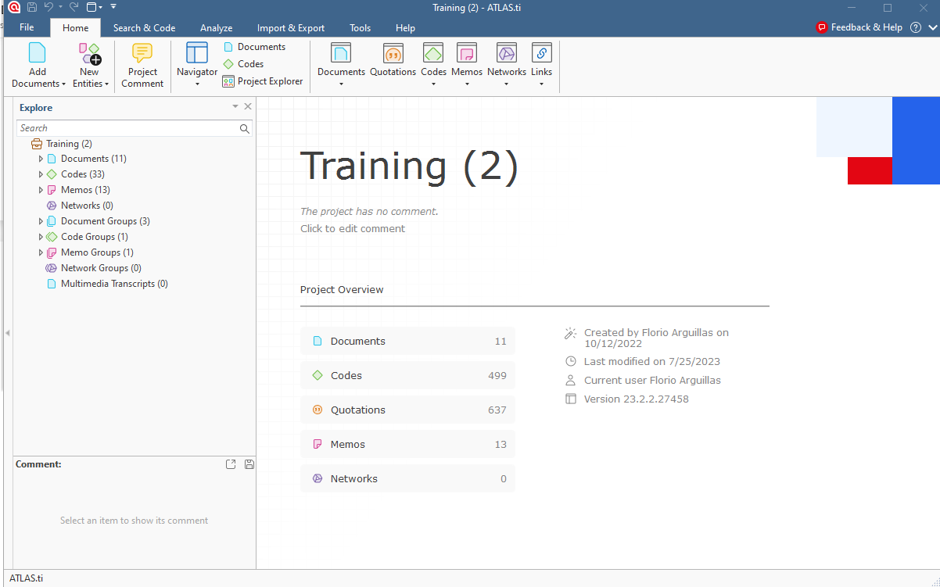

**Tips!**

* Right-click is your friend!
* Explore/Experiment with the tools
* Test your analytic strategy with a sample of your documents before applying it to the rest.

**Project File**

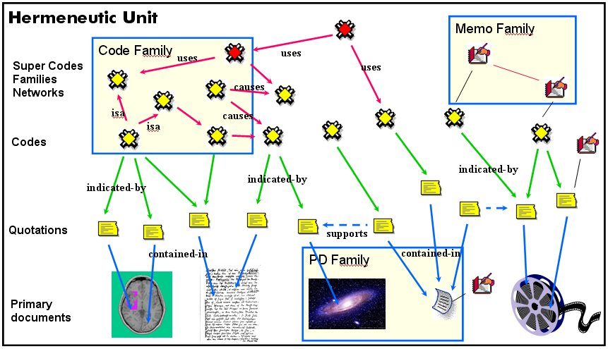

**Atlas.ti Data Management**

When you add primary documents to your project, Atlas.ti copies them and stores them in Atlas.ti’s default library, which is a special repository pointing to this location:

C:\Users\<your username>\AppData\Roaming\Scientific Software\ATLASti

Once these documents are copied to the library, ATLAS.ti will use these documents in the library instead of your original documents.

You can redirect the library to your desired folder location, but this must be done before creating a project.

Here are recommended steps for managing your project files and library:

1. Create a project folder. You put your qualitative data in this folder. Feel free to create sub-folders to organize your files.

We already have a project folder, which we call *AtlastiProject.*

1. Within the project folder, create a sub-folder for your library. Call it *Atlasti23_Library*

Atlas.ti will make a copy of each document you add to your project in the library and will use the copy instead of the original one.

The library is also where your project will be saved by Atlas.ti.

1. Open Atlas.ti 23

Click *Start> Atlas.ti 23*

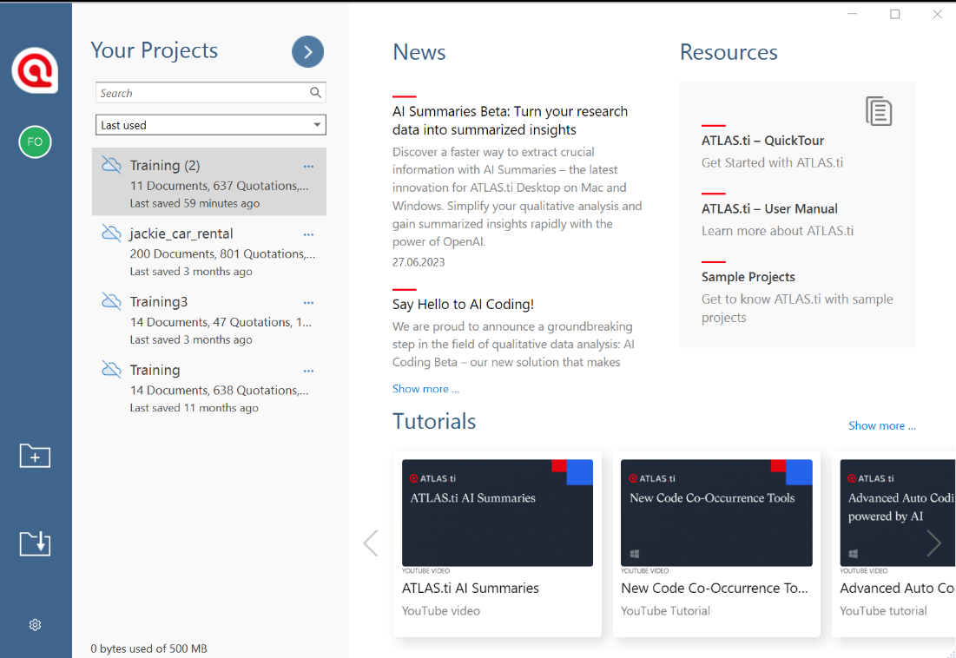

1. Redirect the library. Click *Options* (bottom left corner of Atlas.ti start window)

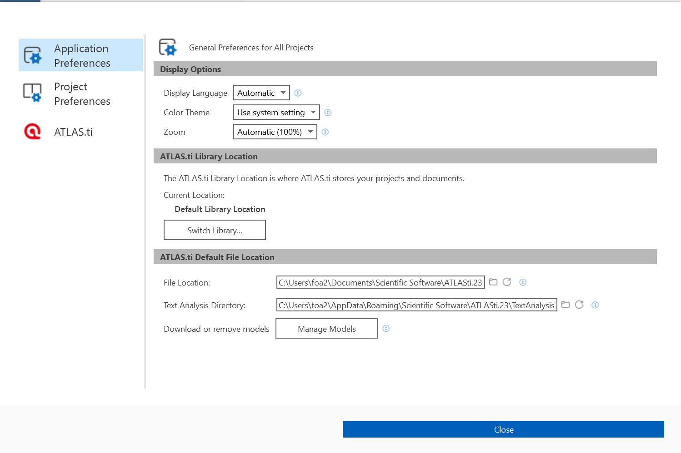

1. Click *Switch Library*

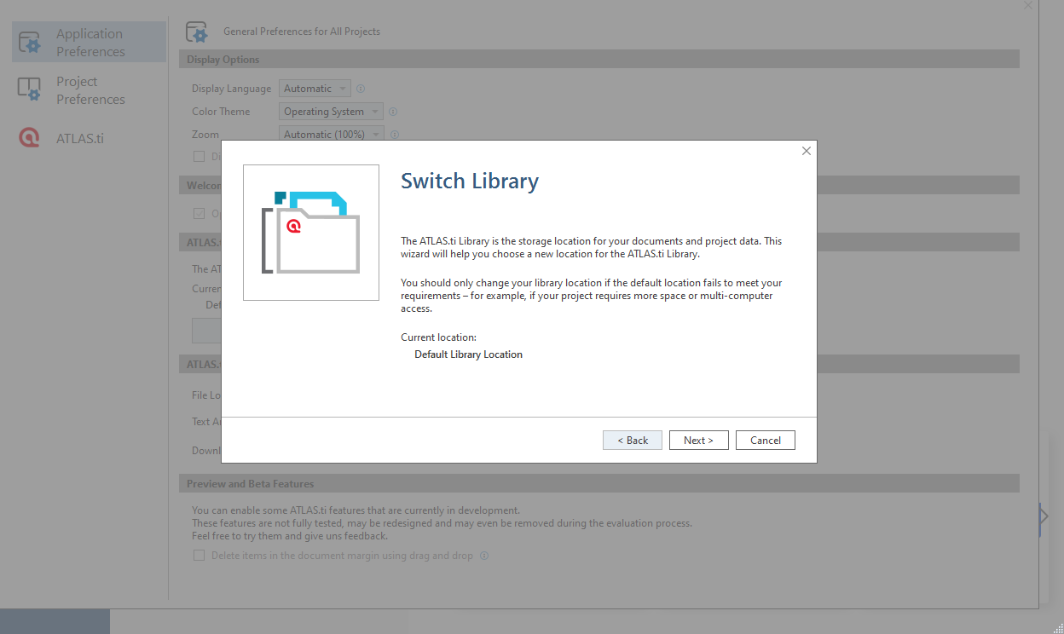

1. Click *Next*
2. Choose *Create a new empty library*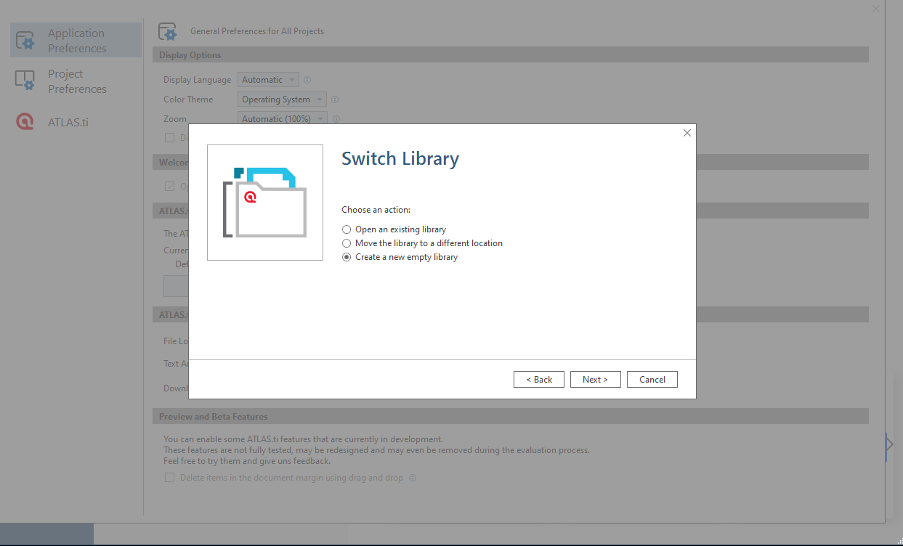
3. Click *Next*

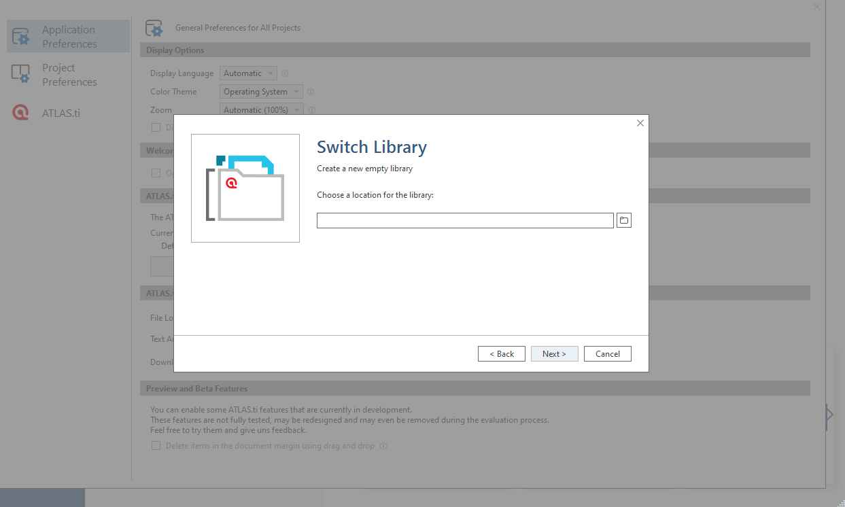

1. Click the Browse folder icon and navigate to your library folder. The example below navigated to *C:\Users\foa2\Atlasti_Training\Atlasti23_Library*

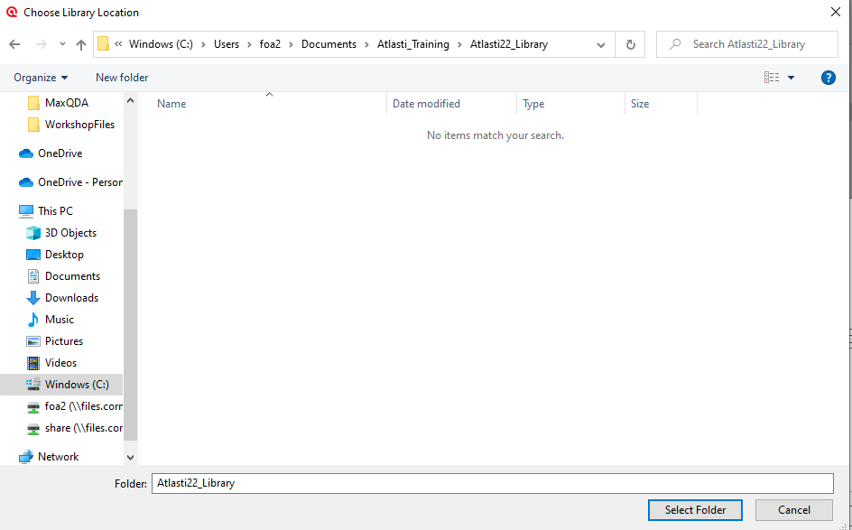

1. Click *Select Folder*

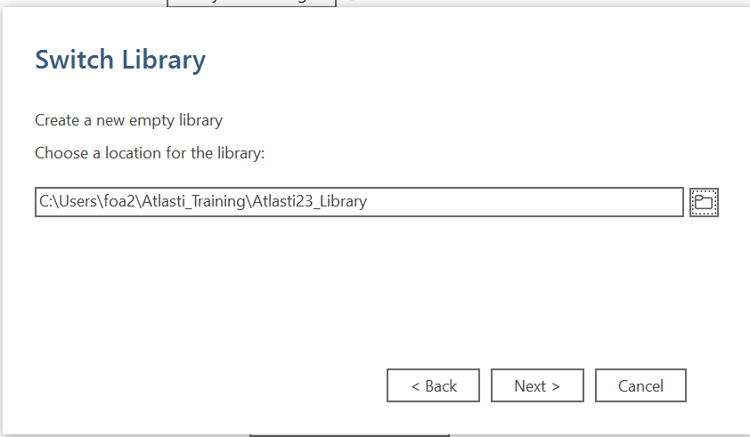

1. Click *Next*

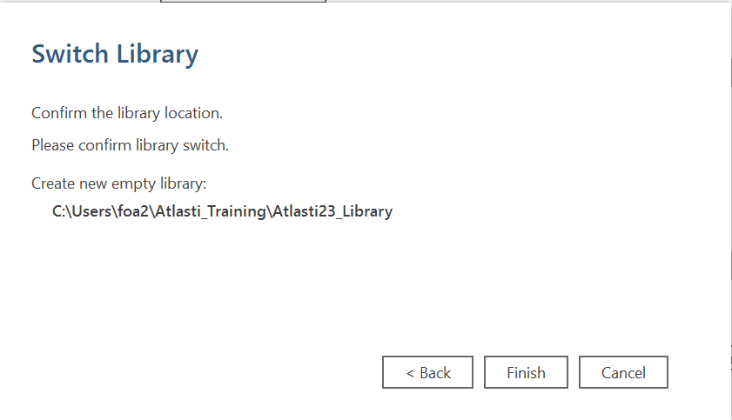

1. Click *Finish*
2. **Create a new project:**

Click *New Project* (folder with + icon), name it **Training,** and click *Create.* This project is now ready to receive all your primary documents.

1. **About saving a project:**

Go to *File>Save…*

**Note:**

There is **NO** File>Save As… option in Atlas.ti. You cannot save your project file to a different folder. Atlas.ti will save your project in the library folder you selected. Atlas.ti will manage the entire project for you. The only way to create a backup of your project is to *File>Export>Project Bundle*.

1. **To write a comment on your project:**

You can attach a comment to your project. For example, you can describe it, date it, write information about what it contains, etc.

In the Explore panel, right-click on the project name *Training*, click *Edit Comment*, type your comment *“This is my Training Project,”* and click *Save.*

You can see the comment at the bottom-left panel of the Atlas.ti workspace.

**Entity Managers**

Primary Documents, quotations, codes, memos, networks, links, memos, and the project explorer are called **“entities.”** Each entity can be linked to other entities and have a comment attached. Atlas-ti keeps track of all such links and dates of creation and modification, authors and path of the source files, etc. Each entity has its manager where you can access and manage relevant tools. These are called **Entity Managers**, i.e., Documents Manager, Quotations Manager, Codes Manager, Memos Managers, Networks Manager, Links Manager, and Project Explorer Manager.

1. **To access an Entity Manager:**

Familiarize yourself with entity managers.

*Double-click* on *Documents* in the Explore panel, then close the tab by pressing X

*Click Home>Documents* in the Managers group.

Do the same for the *Codes* Manager.

**Tip:** All Atlas-ti Entity managers offer alternative access to the same functions found under the main menu.

**Primary Documents (PDs)**

Your primary documents are all the files containing your data. These can be text, image, video, or audio files.

1. **To add a primary document to a library**

First, ensure your data files have the proper format (see Atlas-ti Manual). Atlas-ti can operate on various text file formats (DOC, HTML, RTF, TXT, PDF, etc.). All documents added to the project are copied, and the copies become internal Atlas.ti files. This means, strictly speaking, that ATLAS.ti no longer needs the original files. However, keeping a backup copy of your source files is strongly recommended.

Click *Home > Add Documents* > Add File(s)

Navigate to the *AtlastiProject* folder and select all *Word (.docx)* documents.

Locate the file(s) to add to your library. As usual, you can add multiple files simultaneously (using the Shift or the Ctrl keys). When done, Click *Open*. All added documents will appear in the Explore panel under *Documents.*

To **activate** a PD or have its **content displayed** on the screen so you can work on it, click on the PD in the PD Manager or the Explore panel’s Documents folder.

**To view multiple PDs.**  Each time you open a PD, it is displayed on a different tab.

To **remove** a PD from the Project, select it in the Explore Panel or Document Manager, right-click it, and then choose *Delete.*

You can add a **comment** to a PD too!

Select it in the Explore Panel or Document Manager, right-click on it, then select *Edit Comment.*

To save your comment, Click *Save.*

You **can edit** PDs.

Open the Document and click the *Edit Document* tool.

**Primary Document Manager**

This manager gives you access to the primary document that includes the number and name of each PD and other information such as creation date, location, author, number of quotations, etc.

Two possible ways to access the PD manager:

1. Go to the Explore panel and double-click on the *Documents* tab
2. Go to *Home* and double-click on *Documents*

**PD Document Groups**

You can create clusters of PDs called PD Document Groups. They are used to group your documents on specific PD characteristics. It is also used to filter your set of PDs to reduce the number of documents or focus your queries and outputs. For example, you create a group of male and female respondents, specific geographical areas, or age groups.

To assign PDs to Document Groups, select the PDs belonging to the same family and drag them into the Document Groups panel on the left. This opens a *Create Document Groups* dialog box. Enter the name of the group and hit OK.

1. **To create a PD Group**

On the PD Manager, ctrl-click to select *Barbara, Dorothy, Helen, Margaret, and Susan*, and drag them to the Document Groups panel on the left. Name the group *Females* and hit *Create*.

To remove PDs from a Document Group, select the group, right-click the PDs you want to remove from that group and select *Remove from Document Group*.

To filter a project based on Document Groups, right-click on the filter group (e.g., *Females*) on the Document Groups panel, then select *Set Global Filter.*

To unfilter a project based on Document Groups, right-click on the filter group (e.g., *Females*) on the Document Groups panel, then select *Remove Global Filter.*

**Quotations**

Creating quotations is the start of your analytical process. A quotation is the building block of your grounded theory. It is a continuous passage of text, an audio or video clip, or an image region. It can be as short as a single character and as large as the whole PD. You often create quotations as you link them to a code or another quotation (hyperlink) to retrieve them later in an organized and significant fashion. You can attach a comment or a memo to a quotation. You can also create a “free quotation.” This means it is not assigned to a code or linked to anything. Some quotes are often left free so researchers can revisit them when they fully grasp the concepts and assign the appropriate code.

1. **To create a free quotation**

*Open a PD. Highlight a relevant passage*, right-click on it, and select *Create Free Quotation*

**Codes**

Codes are the key ideas or concepts you discover or gather from the selected passage. They can be provisional or permanent and linked with other codes to form a conceptually dense theory.

Atlas-ti offers many ways to link a code to a quotation. You must highlight the relevant quotation first, then right-click on the selected passage. You will have choices for types of coding. You can also link a code to another code, link it to a memo, or attach a comment to a code to describe it.

Below are some approaches to the most common types of coding.

1. **Open the Barbara transcript**. Scroll down to the pre-highlighted passages (instructor did this, so it is easy to spot) and code the following:
   * 1. All Yellow highlighted passages code as *Due to environmental impacts.*

**Coding Method 1:** Highlight passage>right-click and select *Apply Codes*>enter code *Due to environmental impacts,* then press Enter or click the + sign or double-click

**Coding Method 2:** Highlight the other passage to be coded the same> right-click and select *Quick Coding* and select *Due to environmental impacts*

Quick coding repeats the last code used. This is useful when looking for several passages with the same idea as the previous code.

* + 1. All Bright-Green highlighted passages code as *Due to foreign competition*

Use Coding Method 1 approach.

* + 1. All Turquoise highlighted passages code as *Due to costs of doing business*

Use Coding Method 1 approach.

1. **Open Charles’ interview:** 
   1. Scroll down to the pre-highlighted passages and code the following:
      1. All Pink highlighted passages code as *Due to natural variation*

Use Coding Method 1 approach.

* + 1. All Turquoise highlighted passages code as *Due to costs of doing business*

**Coding Method 3:** Highlight the passage, right-click and click Apply Codes, then select *Due to environmental impact,* then press Enter or click the + sign or double-click.

Applying existing helps avoid making a spelling mistake and allows you to check if the code you plan to assign is already on the list.

1. **Open Maria and Daniel’s interview**:
   1. Scroll down to the pre-highlighted passages and code the following:
      1. All Yellow highlighted passages code as *Due to environmental impacts*

**Coding Method 4:** Highlight the passage. On the Explore panel, expand *Codes*, select *Due to environmental impacts* and drag it over the highlighted passage.

* + 1. All Bright-Green highlighted passages code as *Due to foreign competition*

Use Method 3

* + 1. **Coding Method 5:** Select any passage, right-click, and choose *Code in Vivo*

This automatically gives the code a name made of the first 30 characters of the passage.

1. **Create a Free Code**

Open the Codes Manager, click on *Free Code*, and enter *Reasons for decline in the fishing industry*

**Unlinking codes**

UNLINK the code to remove the link between the code and the quote. Go to the quote, right-click on its coding stripe, then choose *Unlink*. Note that this will not erase the code from the code list and its association with other quotations.

**Deleting codes**

To permanently erase a code and all its associations with any quotation or memos or other codes, use DELETE. To do this, highlight the code in the Codes Manager, right-click, and select *Delete.* If you changed your mind, there is an UNDO function!

**Code-to-code relations and the relation editor**

*Note: Relation Editors for code-code relations and Hyperlinks (quotation-quotation links) are similar.*

You can establish links between two codes or quotations as soon as you see them. These relations could reflect precedence in time, causation, explanation, or whatever you want it to be.

1. **How to assign pre-defined relation between two codes or quotations:**

Step 1. Open the Codes Manager, then click and drag the anchor code (*Due to environmental impacts*) and release it over the target code (*Reasons for decline in fishing industry*).

Step 2. Chose an existing relation (*is cause of*) from the relation editor. This assigns a relationship between two codes.

1. **How to create a new relation (or link) between two codes or quotations:**

To create a new relation, follow Step 1 above, but when the Relation Editor pops up as you set the target code, do the following:

Click *New Relation Type*

Name: *emphasizes*

Color: *Red*

Property*:* *Asymmetric*

*Symmetric* - if *a* is related to *b* then *b* is related to *a* ;

Bi-directional; reciprocal

*Asymmetric* - uni-directional; not reciprocal

A leads to B; B does not lead to A

*Transitive* - a transitive relation exists between two elements if it is related to a third element similarly.

If A = B and B=C, then A=C

Click *Create*

To modify relations, click on the *Links Manager*, click *Relations*, then select *emphasizes* on the list.

Modify the following:

Short name*:* *E* (explicit wording or just a letter not yet used)

Symbolic name: *>>>>>* (choose a unique graphic symbol)

*Preferred layout direction:* used to automatically draw the picture when opening a Network View on an object.

*Line Width, Line style:* determine your display preferences.

**Memos**

Memos can be used to document your analytical thoughts, progress, processes, methodology, emerging concepts, theories, etc., or as simple reminders. You can write into a memo screen directly, insert pictures, and stamp the date. You can attach a memo to a quotation, code, or other memos. You can search, retrieve, or output your memos. Explore the memo manager.

1. **To create a memo**

Go to *Home>Memos Manager>Memos>Create Free memo*, then enter a name for the memo (*Reasons for Decline in Fishing Industry*)

A memo dialog screen opens, allowing you to write a memo, insert pictures, and put timestamps.

Save by clickingthe *Save* button on the Memo window.

1. **Linking Memos to Code and Quotes**

By linking quotes or codes to memos, you connect your analysis directly to your sources, so you can easily retrieve them when needed.

On the Explore panel:

1. Drag and drop the memo *Reasons for Decline in Fishing Industry* onto Quotation 1:1
2. Drag and drop the memo *Reasons for Decline in Fishing Industry* onto the code *Due to environmental impacts*
3. Open the Quotations Manager and from the Explore panel,drag-and-drop the memo *Reasons for Decline in Fishing Industry* onto Quotation 1:2

**Outputs**

You can output the results of your work to an Atlas.ti editor via Report and save them to a file. Each entity manager offers a different type of Report. Explore them.

*Go to the Documents, Quotations, Codes, or Memos Manager, select some or all entities you want to report on, then click Report.*

A Report screen pops up with options for results that would be included in the output. Accepting the default settings should be fine (but feel free to test various settings). Then click *Create Report.*

1. **Creating a Report**

In the Codes Manager:

1. Select a code or codes (*Due to environmental impacts*)
2. Click *Report*
3. Check the boxes next to the output you want. I typically choose the default where Comments, Quotations, and Content (under Quotation) are checked.
4. Click *Create Report*. This opens a text editor with quotes about *Due to environmental impacts* gathered from across all documents (unless filtered) in the project.
5. Click *Save* to save the output either as PDF or DOC.

**Networks**

A “conceptual” Network is created in the background as soon as you link any two objects in your Project. For example, when you make a quotation in a PD, Atlas.ti establishes a link between that PD and the quotation, which starts the network. Each time you link a code to a quote or another code, it enriches the network.

You can view and manipulate subsets of the network through the Network Editor and Networks Manager. Two entities are “linked” together by a “relation” (remember the relation editor, the code-code relation, and hyperlinks discussed earlier).

The Network Editor lets you create and manipulate network structures. You can add nodes, reroute edges, change the layout, change relations between nodes, visually connect codes and other objects, save the network, and export as a picture.

Use the drag-and-drop method with the available tools and by mouse right-click.

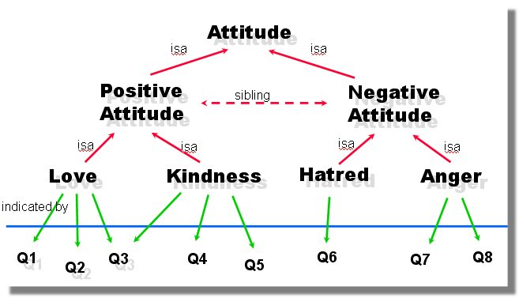

**Two ways to open/create a Network.**

1. *Open the Networks Manager>Networks*, then click *Create Network*
2. Open an Entity Manager (e.g., Codes Manager), select one or more entities, then click the *Open Network* tool or right-click and select *Open Network*. A Network Editor opens and displays the selected entities and their linkages.

**Importing or bringing additional nodes into the Network Editor**

1. Click Nodes> Add Nodes

**Selecting Nodes and Links**

1. single node – left click
2. multiple nodes – Ctrl-click
3. multiple nodes – Marquee selection (upper left corner to bottom right corner)
4. Links – click on the label of the link

**Deselecting Nodes and Links**

Hold down the **Ctrl** key and click on the selected node or link.

**Moving Nodes**

1. single node – click and drag
2. multiple nodes – Ctrl-click and drag
3. multiple nodes – Marquee selection (upper left corner to bottom right corner)

**Linking Nodes**

Linking nodes in a Network Editor is another way to establish links between nodes.

Linking two nodes

* click a node
* Drag the connector to the target node, then release the mouse
* select a relation

**Cutting Links**

1. Select and right-click on a link and choose *Unlink*
2. Click on a link, this active the Links group, then select *Unlink*

**Modifying Links**

Right-click on **a link** and select Change Relation

**Importing Node Neighbors**

Imports all direct neighbors of the selected nodes into the Network View. Direct neighbors are quotations and codes linked to the code.

Allows you to construct a connected network view step-by-step.

Highlight a node (e.g., a code), then click ***Nodes>Add Neighbors.***

**Import Co-occurring Codes**

To import codes that are near the selected code.

Select Code and click ***Nodes>Add Co-Occurring Codes***

**Removing Nodes from the network**

Removing nodes removes the node from the Network View.

Select node, then right-click and select *Remove from Network.*

**Creating Output**

1. Print entire or partial network

**(Export>Print)**

1. Save Network as Graphic File

**(Export>Export Bitmap)**

**Merging Codes using the Network Editor**

You may want to merge synonymous codes.

Select two codes, then click ***Nodes>Merge Codes.***

**Special tools**

Under “**Tools**” on the main menu, you can access a choice of special tools to help you find what you are looking for in your project. Some usual tools are summarized in the table below.

**Search Project**

1. **Click *Tools*>*Search Project> Search Term>***

The text search tool is used to search simple strings, categories, or sophisticated pattern match (GREP).

Try:

*fish* (finds words with *fish*)

*fish environment* (finds sentences or paragraphs that have the words *fish* AND *environment* that may or may not be adjacent with each other)

*fish|environment* (finds sentences or paragraphs that have the word *fish* OR *environment*)

GREP Search - GREP is a well-known tool in the UNIX environment. Stands for ***Globally look for Regular Expression and Print.***

It includes special characters in the search string that control the matching process:

e.g., 200[0-9] -- Finds all years between 2000 and 2009

:d:d -- Finds all numbers with two digits

^.: -- Finds all lines (paragraphs) starting with one arbitrary

letter followed by a colon:

**Auto-Coding**

Auto-Coding finds text passages based on specified search terms and strategies and then codes the passages. It combines the Text Search tool with an automatic segmentation and code assignment mechanism.

**30. To Auto-Code:**

Right-click on a Document (or Documents) and choose ***Search & Code***

Choose a Search Strategy--*Text Search, Regular Expression Search, Named Entity Recognition, Sentiment Analysis*.

Click *Continue*

Using natural language processing, Atlas.ti will parse a sentence or chunk of text to find the text you are searching for.

**Strategy:**

**TEXT** if you want to find a word containing the characters you entered in the search text box, e.g., *child*. If you check the box *include inflected forms*, ATLAS.ti will also find *children, childhood, childless, childish*, etc.

**REGULAR EXPRESSION** allows you to build search terms using regular expressions. An example would be to search for ‘kid|children|youngster|minor.’ The pipe | as regular expression means OR. Given the above search time, ATLAS.ti will search for any occurrences of the words in the term.

**NAMED ENTITY RECOGNITION** Atlas.ti goes through your data and finds entities for you such as Persons, Locations, Organizations, Miscellaneous (works of arts, languages, political parties, events, the title of books, etc.).

**SENTIMENT ANALYSIS** Using text analysis techniques, Atlas.ti interprets and classifies emotions (Positive, Neutral, Negative) within text data.

**Context:**

Activated only if you select the following strategies: Expression, Regular Expression

Sentence – the two words should be in the same sentence.

Paragraph – the two words should be in the same paragraph.

Tip: Test search patterns with Text Search Tool before using Auto-Coding Tool to avoid an imprecise search.

**Try these examples:** Select All or some documents to autocode

Search & Code: *Text*

Find: *Paragraph*

Search For: *fish*

Apply codes: *fish*

Search & Code: *Text*

Search For: *fish*

Click *Add*

Search For: *environment*

Apply codes: *fish and environment*

Search & Code: *Regular Expression*

Find: *Paragraph*

Search For: *fish|water*

Apply codes: *fish or water*

Search & Code: *Regular Expression*

Find: *Paragraph*

Search For: *Q.[0-9].*

Apply codes: *Questions*

Search & Code: *Named Entity Recognition*

Find: *Paragraph*

Accept default settings (Persons, Locations, Organizations, Miscellaneous)

Click *Continue*

Click *Select All (so results will be displayed)*

Click *Show Results*

Select *Apply Proposed Codes*

Search & Code: *Sentiment Analysis*

Find: *Paragraph*

Accept default settings (Positive, Neutral, Negative), and click *Show Results.*

Select *Apply Proposed Codes*

**31.**  **AI Coding and Summaries**

<https://atlasti.com/atlas-ti-ai-lab-accelerating-innovation-for-data-analysis>

Powered by the technology behind ChatGPT from OpenAI.

**Search & Code: AI Coding**

Uses Open AI to code your data automatically–provides coding suggestions Select Documents or Document Groups

**Search & Code: AI Summaries** (Uses Open AI to summarize your document)

Select Documents or Document Groups

**Note**: Both options send your data to Open AI for processing

Is Open AI Secure? [Security (openai.com)](https://openai.com/security)

***Analytic Approach***

* Gather all segments related to a particular research topic by assigning a code.
* On the Explore panel, right-click on the code, select Analysis>AI Summaries

**The Word List**

This is used for simple quantitative content analysis.

**32. Open a Document, Quotation, or Code Manager> select an entity or entities, then choose Word List.**

**The Word Cloud**

This is used to visualize the dominant words in the text—a quick way to get a feeling of the content of a text document.

**33. Open a Document, Quotation, or Code Manager> select an entity or entities, then choose *Word Cloud***

**Codings Analyzer (Redundant Coding Analyzer)**

Finds codes with redundant coding, i.e., two overlapping passages assigned the same codes. This tool is used to clean up codes.

34. Go to **Tools>Find Redundant Codings**

The Upper pane lists all codes with redundant coding. The lower pane displays the two overlapping quotations. Double-clicking the quotation shows it in context. Its contents are also displayed at the bottom of the pane.

You have the option to unlink or merge quotations.

**The Query Tool**

The Query Tool is used to retrieve quotations with two or more codes associated with them. It is a powerful tool to find quotes that meet specific conditions and automatically code them.

Go to **Analyze>Query Tool**

A query tool dialog box appears with four panels – Code, Code Groups, Term (Query Expression), Quotations. A Scope can be added,

Operands and Operators are the main ingredients of the query. The operands are the codes and code groups. The operators are boolean (Set), semantic and proximity operators.

When querying, it is common to specify an operand first (code), then an operator, then another operand (code). The query condition can become complex with more operators and operands added, but complex conditions are usually rare, although it does happen.

**Boolean Operators**

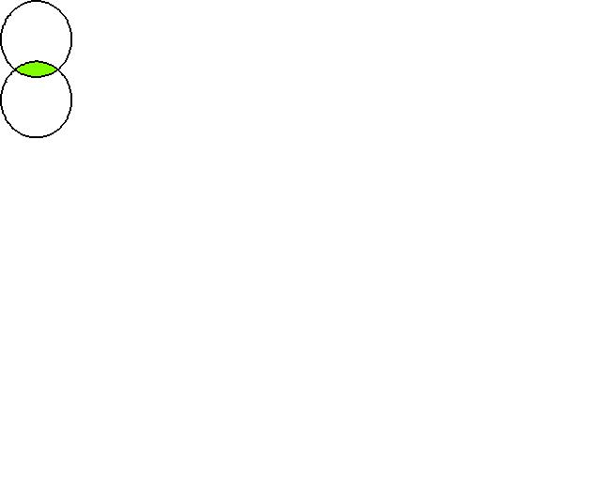

Water

Fire

AND

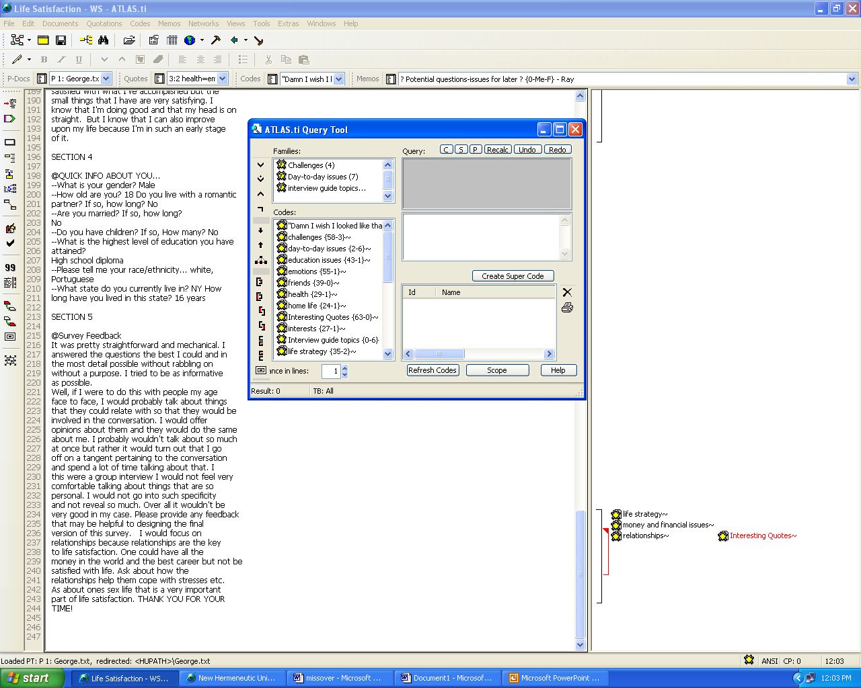

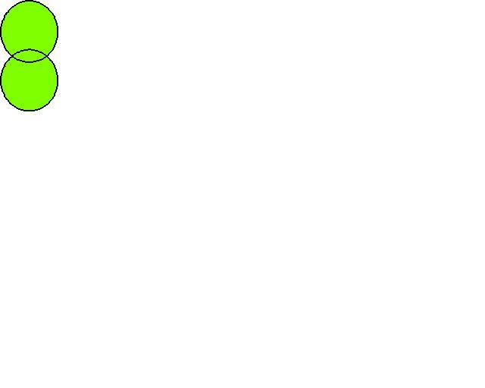

Water

Fire

OR



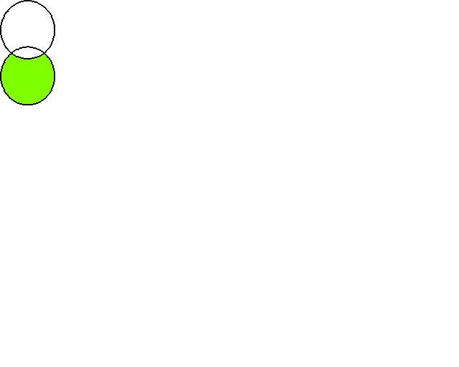

NOT



Water

Fire

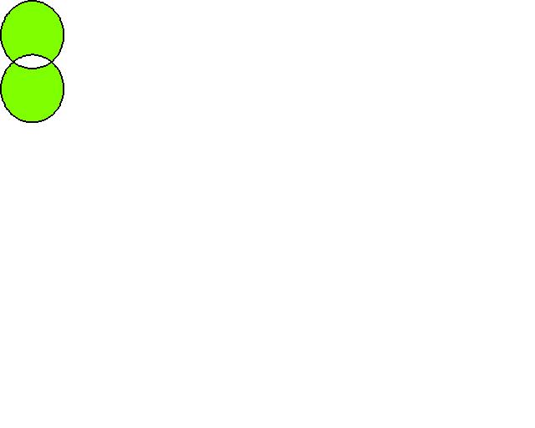

XOR





Water

AND

Fire

Water

OR

Fire

NOT

Water

Either Water

or

Fire, but not both

Water

Fire

**Semantic Operators**

This exploits the network structures that were built from the codes. Works only if the code has a code related to it in a transitive way. Only “transitive” relations between the codes are processed; all other types of links are ignored.

**DOWN**  button – traverses the network from higher to lower concepts. Treats the code at the receiving end of the arrow as the higher concept.

Displays the quotes of all the codes with which the selected code has transitive relations, excluding the code chosen sections. Quotations given multiple codes will be displayed only once.

**UP** button - Displays the quotes of the selected code plus the quotes of the higher-level concept(s). Quotes given multiple codes will be displayed only once.

**SIBLINGS** – finds all quotations connected to the selected code or any other descendants of its parents.

**Proximity Operators**



**35. How to use the Query Tool**

Double-click on the first code ofinterest (*Due to the cost of doing business*) from the code pane. It appears on the operand box of the expression builder.

*Choose the operator by clicking on its icon on the toolbar* (Here choose the proximity operator “OVERLAPPED BY”)

Double-click on the second code of interest *(Due to environmental impacts*

It appears on the top query pane under the first code. Matching quotations are displayed at the bottom panel of the query pane.

Click on the Operator icon in the expression builder to see the results.

To **change the scope** of the query:

Click on *Scope Tool>Edit Scope*

Double-click on the Documents of Document Groups that you want to focus your query on. This will apply to your scope criteria.

To **save the results as a code**

Click *Save Smart Code*, give it a name, and hit Create

-It’s a smart code because if new quotations that meet the conditions are added to the project, you do not have to re-run the query. It will automatically apply the smart code to the quotations.

**36. Explore the Co-Occurrence Table**

Analyze>Co-Occurrence Table

A table showing the frequency of co-occurrence of codes that may suggest patterns and simultaneously provides a way to examine these co-occurrences in context.

**37. Explore the Code-Document Tables**

Go to **Analyze>Code-Document Table**

1. Check the box(es) next to the code(s) you want to be displayed on the table
2. Check the box(es) next to the document(s) you want to be displayed on the table
3. On the Table group of the toolbar, click on *Codes as Columns* to transpose the table
4. Click on the number in the cell where the code intersects with the document. This will list the quotations assigned to that code on the right
5. Double-click on a quote to display the quote in context
6. To assign the quote a new code, select the quote by right-clicking on the bar that corresponds to the quote, selecting Apply Codes, and applying a code.
7. If necessary, you can unlink the original code from the quote.



**38. Working with PDF file**

Click *Home>Add Documents> Analyzing Estuarine Shoreline Change~ A Case Study of Cedar Island, North Carolina.pdf*

**Coding text:** *Highlight a segment of text you want to code, then code it.*

**Coding an image:** *Select a region using marquee selection, then code it.*

**39. Working with Video file**

Click *Home>Add Documents> Add Files> Betty and Paul.wmv*

Associate a transcript*:* With *Betty and Paul.wmv* file open, click *Tools>Import Transcript>Betty and Paul_otter.ai*

Note: There’s a new entry in the Project Explorer under the Multimedia Transcripts branch

Editing a transcript: Open transcript, then click *Edit* (under Document). This puts the transcript in editing mode. When done edit, click *Exit Edit Mode*, then save (or cancel) edits**.**

Coding a segment of a video file: Position your mouse on the left-hand side of the audio wave to mark the start of the quotation and drag it either to the right-hand side or the left-hand side and release to mark the end of the quotation and create it. Then code the quote.

Familiarize yourself with:

* 1. Playhead – shows the current position of the playhead in the video
  2. Document preview – a preview of the entire document (located below the display area)
  3. Preview Images – displays keyframes in video file
  4. Audio wave
  5. Media controls

**40. Working with Audio file**

Click *Home>Add Documents> Add Files> Helen.mp3*

Editing a transcript, creating quotes, and assigning codes similar to the video file above.

**Export Project Bundle**

This tool facilitates procedures to migrate and backup your entire project.

To **create the bundle** before migrating:

Go to *File> Export> Project Bundle*

A saving dialog box opens, asking for a filename and directory to save the bundle. The extension name of the bundle is **.atlproj**. It can be saved anywhere you want.

After answering these questions, *click Save* (Atlas-ti then creates and saves the bundle.)

Tip! Good idea to Project bundle your file often and to keep the date in the filename, which is added by default. Include multimedia files in your project bundle when asked.

To **install the bundle** at its new location:

Open Atlas.ti9>Import Project (folder with down-arrow icon)> select the file

**Export to SPSS**

1. Go to ***Import & Export>SPSS Job***

2. Enter the location and the name of the SPSS data file in the **DATA LIST FILE** box.

For example: C:\AtlastiProject\spssdat *(extension name of this file is .dat)*

3. Then specify the location and name of the file where the SPSS program will be saved.

For example: C:\ AtlastiProject\spssdat *(extension name of this file is .sps)*

4. Then click *Create.*

Note: Atlas-ti will create two files: data file (.DAT) and syntax/program file (.SPS)

In the created SPSS data set, the unit of analysis is the quotation.

The quotation is identified by its:

PD (Primary Document)

QU (Quotation Index)

SL (Start Line)

SC (Start Column)

EL (End Line)

EC (End Column)

TI (Creation Date)

K#variables are Codes

KF# variables are Code Families

PF# variables are PD Families

**Teamwork support**

Atlas-ti supports multiple users/ authors working simultaneously on the same project for procedures to follow to prepare your project and set it up correctly.

**Resources**

Buying the Atlas-ti program https://atlasti.cleverbridge.com/74/purl-order

Students: $99, good for two years (<https://atlasti.com/student-licenses>)

Atlas-ti Website (<http://www.atlasti.com/>)

**Useful References:**

Bogdan, R., & Biklen, S. K. (2007). Qualitative research for education: An introduction to theory and methods. Boston: Pearson/Allyn and Bacon.

Friese, Susanne (2019). Qualitative Data Analysis with Atlas.ti. Third Edition. London: Sage Publications.

Tong, Allison, Peter Sainsbury, and Jonathan Craig (2007). Consolidated criteria for reporting qualitative research (COREQ): a 32-item checklist for interviews and focus groups. International Journal of Quality Health Care, 19 (6): 349-357. doi: 10.1093/intqhc/mzm042. Full-text available from: <http://intqhc.oxfordjournals.org/content/19/6/349.long>

Atlas.ti 23 Online Manual for Windows: <https://doc.atlasti.com/ManualMac.v9/index.html>

Other reporting guidelines, besides qualitative:

<http://www.equator-network.org/reporting-guidelines/>